TUGAS 2

- Hasil Kode
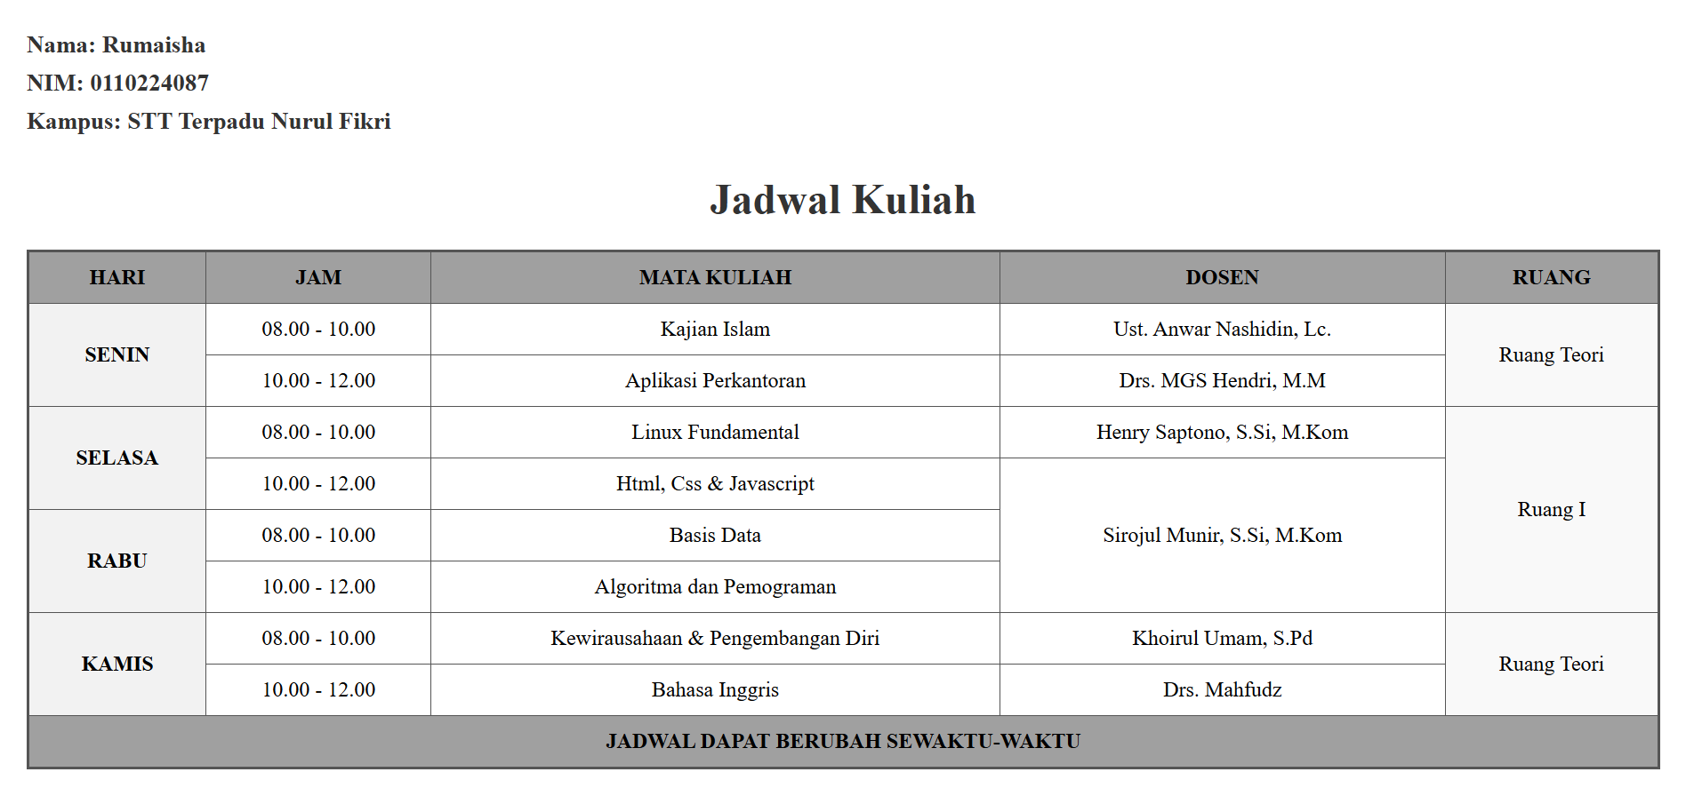

- Kode
<!DOCTYPE html>
<html lang="id">
<head>
<meta charset="UTF-8">
<meta name="viewport" content="width=device-width, initial-scale=1.0">
<title>Tugas Tabel - Jadwal Kuliah</title>
<style>
body {
font-family: 'Times New Roman', Times, serif
background-color: #ffffff;
margin: 20px;
}

.info {
text-align: left;
font-size: 18px;
font-weight: bold;
margin-bottom: 25px;
color: #333;
line-height: 1.6;
}

h1 {
text-align: center;
color: #333;
margin-bottom: 20px;
}

table {
width: 100%;
border-collapse: collapse;
border: 2px solid #555;
}

th, td {
border: 1px solid #555;
padding: 10px;
text-align: center;
vertical-align: middle;
}

/* Warna Header */
th {
background-color: #a0a0a0;
color: #000;
font-weight: bold;
}

/* Warna Kolom HARI */
.hari {
background-color: #f2f2f2;
font-weight: bold;
}

/* Warna Kolom RUANG */
.ruang {
background-color: #f9f9f9;
}

/* Warna Footer */
.footer-table {
background-color: #a0a0a0;
font-weight: bold;
color: #000;
}
</style>
</head>
<body>

<!-- Tugas dibuat oleh -->
<div class="info">
Nama: Rumaisha <br>
NIM: 0110224087 <br>
Kampus: STT Terpadu Nurul Fikri
</div>

<h1>Jadwal Kuliah</h1>

<table>
<!-- Header -->
<tr>
<th>HARI</th>
<th>JAM</th>
<th>MATA KULIAH</th>
<th>DOSEN</th>
<th>RUANG</th>
</tr>

<!-- SENIN -->
<tr>
<td rowspan="2" class="hari">SENIN</td>
<td>08.00 - 10.00</td>
<td>Kajian Islam</td>
<td>Ust. Anwar Nashidin, Lc.</td>
<td rowspan="2" class="ruang">Ruang Teori</td>
</tr>
<tr>
<td>10.00 - 12.00</td>
<td>Aplikasi Perkantoran</td>
<td>Drs. MGS Hendri, M.M</td>
</tr>

<!-- SELASA -->
<tr>
<td rowspan="2" class="hari">SELASA</td>
<td>08.00 - 10.00</td>
<td>Linux Fundamental</td>
<td>Henry Saptono, S.Si, M.Kom</td>
<td rowspan="4" class="ruang">Ruang I</td>
</tr>
<tr>
<td>10.00 - 12.00</td>
<td>Html, Css & Javascript</td>
<td rowspan="3">Sirojul Munir, S.Si, M.Kom</td>
</tr>

<!-- RABU -->
<tr>
<td rowspan="2" class="hari">RABU</td>
<td>08.00 - 10.00</td>
<td>Basis Data</td>
</tr>
<tr>
<td>10.00 - 12.00</td>
<td>Algoritma dan Pemograman</td>
</tr>

<!-- KAMIS -->
<tr>
<td rowspan="2" class="hari">KAMIS</td>
<td>08.00 - 10.00</td>
<td>Kewirausahaan & Pengembangan Diri</td>
<td>Khoirul Umam, S.Pd</td>
<td rowspan="2" class="ruang">Ruang Teori</td>
</tr>
<tr>
<td>10.00 - 12.00</td>
<td>Bahasa Inggris</td>
<td>Drs. Mahfudz</td>
</tr>

<!-- FOOTER -->
<tr>
<td colspan="5" class="footer-table">JADWAL DAPAT BERUBAH SEWAKTU-WAKTU</td>
</tr>
</table>

</body>
</html>

